ETL Using Azure Data Factory – Step-by-Step Guide

🔹 Scenario
Extract data from a CSV file in Azure Blob Storage.
Transform data using Mapping Data Flow (e.g., remove nulls, change data types).
Load into an Azure SQL Database.

Steps to create an Storage Account
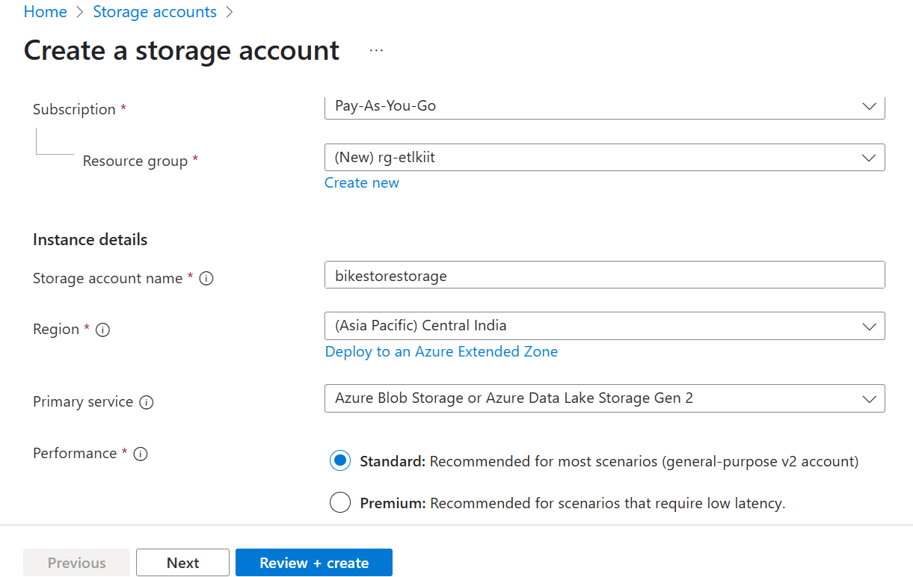

✅ Step 1: Create an Azure Data Factory Instance
1. Go to Azure Portal ➜ Search for "Data Factory" ➜ Click "Create".
2. Fill out:
- Name of the Data Factory
- Resource Group
- Region
3. Click "Review + Create" ➜ then "Create".
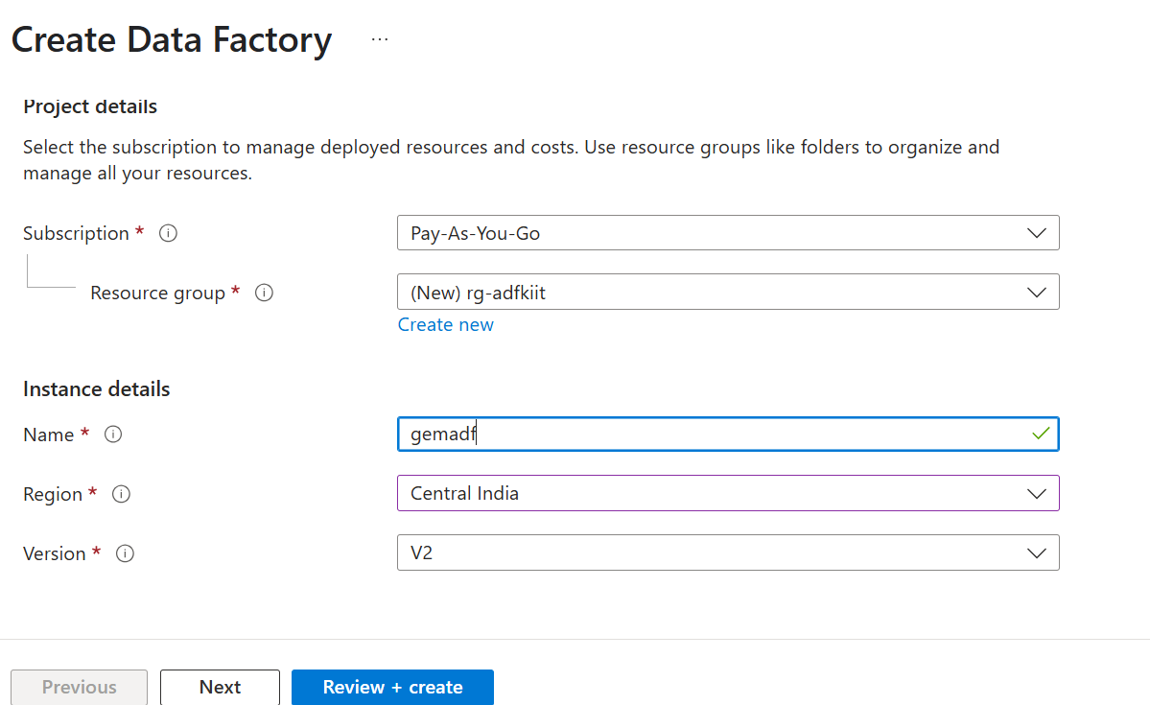
🎯 This sets up the pipeline orchestration environment in Azure.

✅ Step 2: Create Linked Services (Source and Destination)
In Azure Data Factory (ADF), a Linked Service is a connection string definition that acts like a bridge between ADF and external data sources or compute environments.

🔹 Definition:
A Linked Service defines how and where to connect to external resources such as:
- Data stores (e.g., Azure SQL Database, Blob Storage, Data Lake, Amazon S3)
- Compute services (e.g., Azure Databricks, HDInsight, Azure Machine Learning)

🔹 Analogy:
Think of a Linked Service like a connection string in a database application. Just as you need to specify a connection string to access a SQL Server from a .NET app, you need a Linked Service in ADF to connect to a source or sink.

🔹 Key Properties:
- Type: Specifies the kind of service (e.g., AzureBlobStorage, AzureSqlDatabase, etc.)
- Connection string / credentials: Authentication information (e.g., keys, SAS tokens, user/password, managed identity)
- Integration runtime: Determines how the connection is made — via auto-resolve integration runtime, self-hosted, etc.

🔹 Example:
If you want to copy data from an Azure Blob Storage to an Azure SQL Database, you will need:
- A Linked Service to Azure Blob Storage (source)
- A Linked Service to Azure SQL Database (destination)
Each one contains the connection details for its respective environment.

🔹 Types of Linked Services:
Category | Examples
Data Stores | Azure SQL DB, Blob Storage, MySQL
Compute | Azure Databricks, HDInsight, Azure ML
File Systems | Azure File Storage, FTP, SFTP
Others | REST APIs, SAP, Amazon Redshift

🔹 When to Use:
- In datasets (to specify where the data comes from or goes)
- In activities (to define where computation runs, like in Databricks notebooks or stored procedures)

- 🔸 Linked Service for Source (Azure Blob Storage):
- In ADF Studio ➜ Go to Manage ➜ Linked Services ➜ Click New.
2. Select Azure Blob Storage ➜ Name it e.g., LS_BlobStorage.
3. Choose your Storage Account ➜ Test Connection ➜ Create.
- 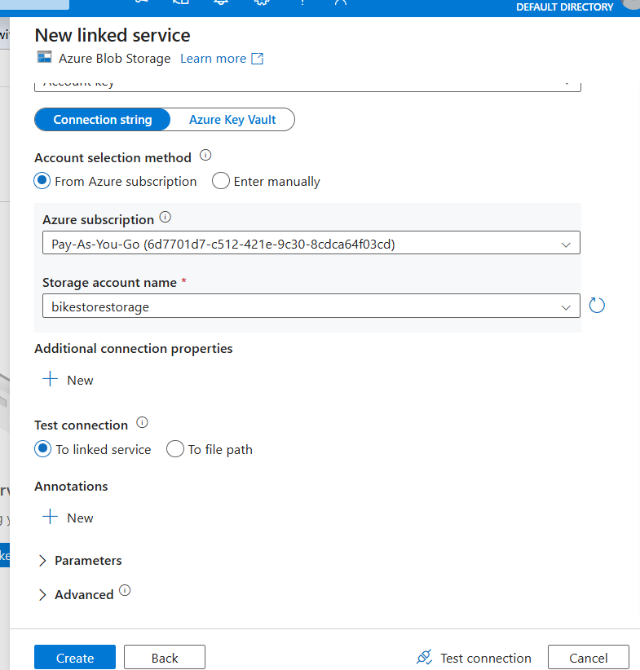
- 🔸 Linked Service for Destination (Azure SQL Database):
To create database
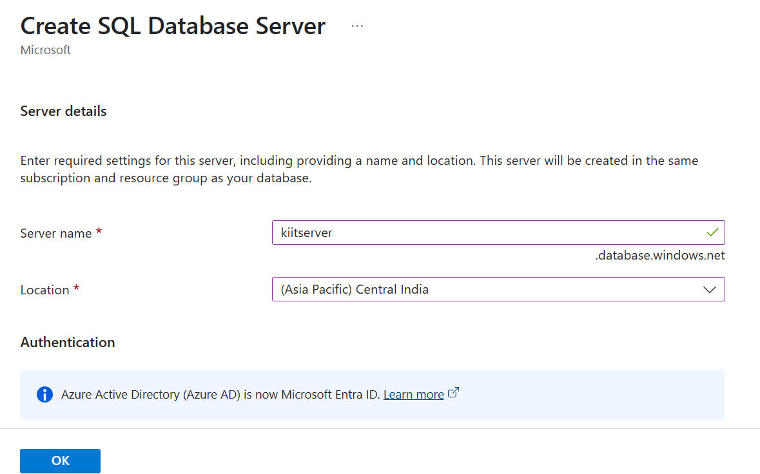
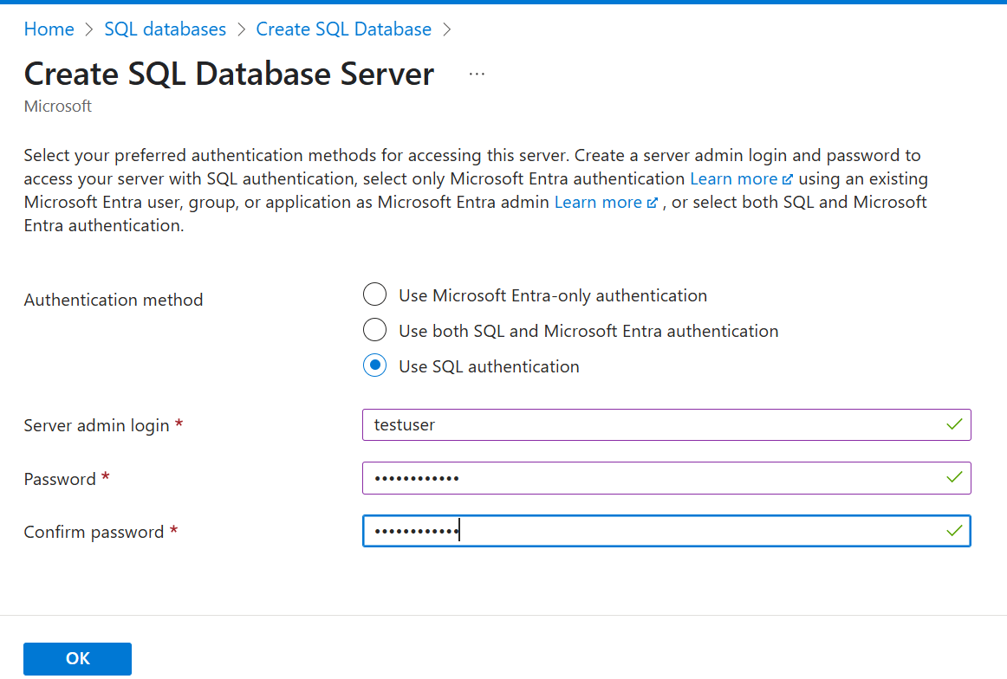
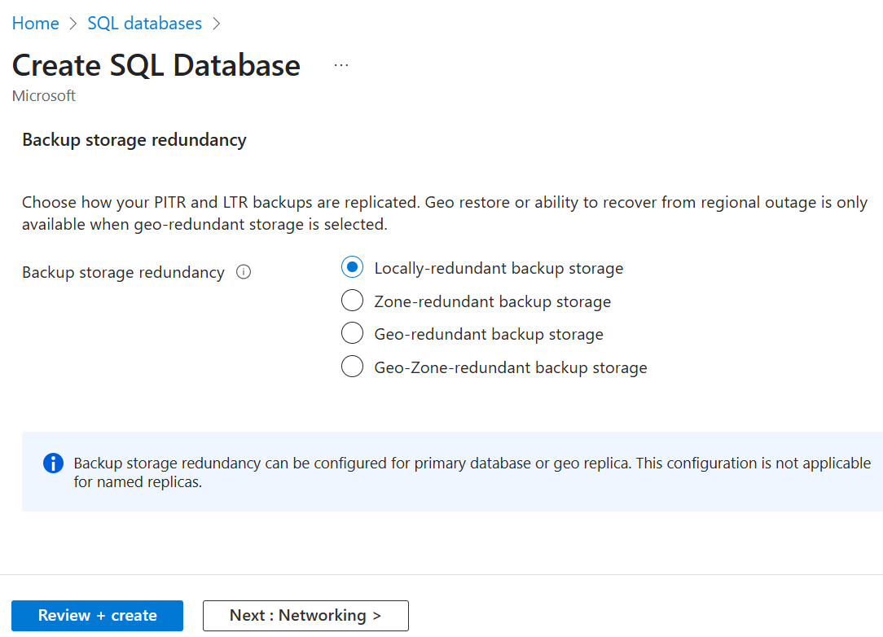
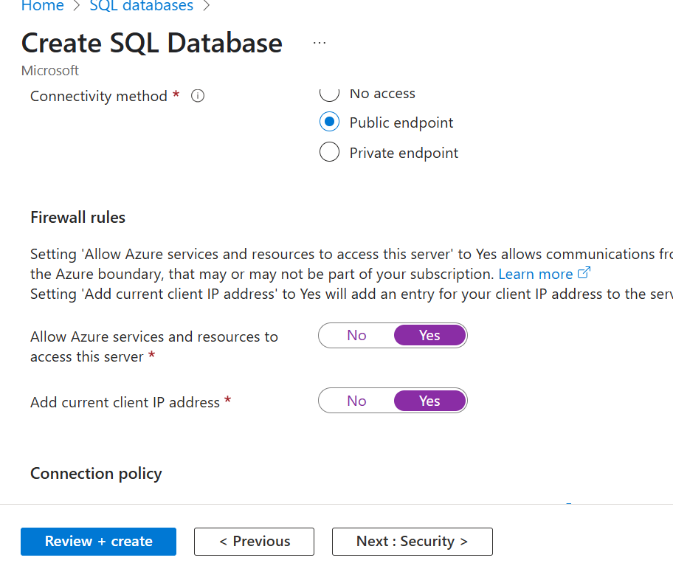
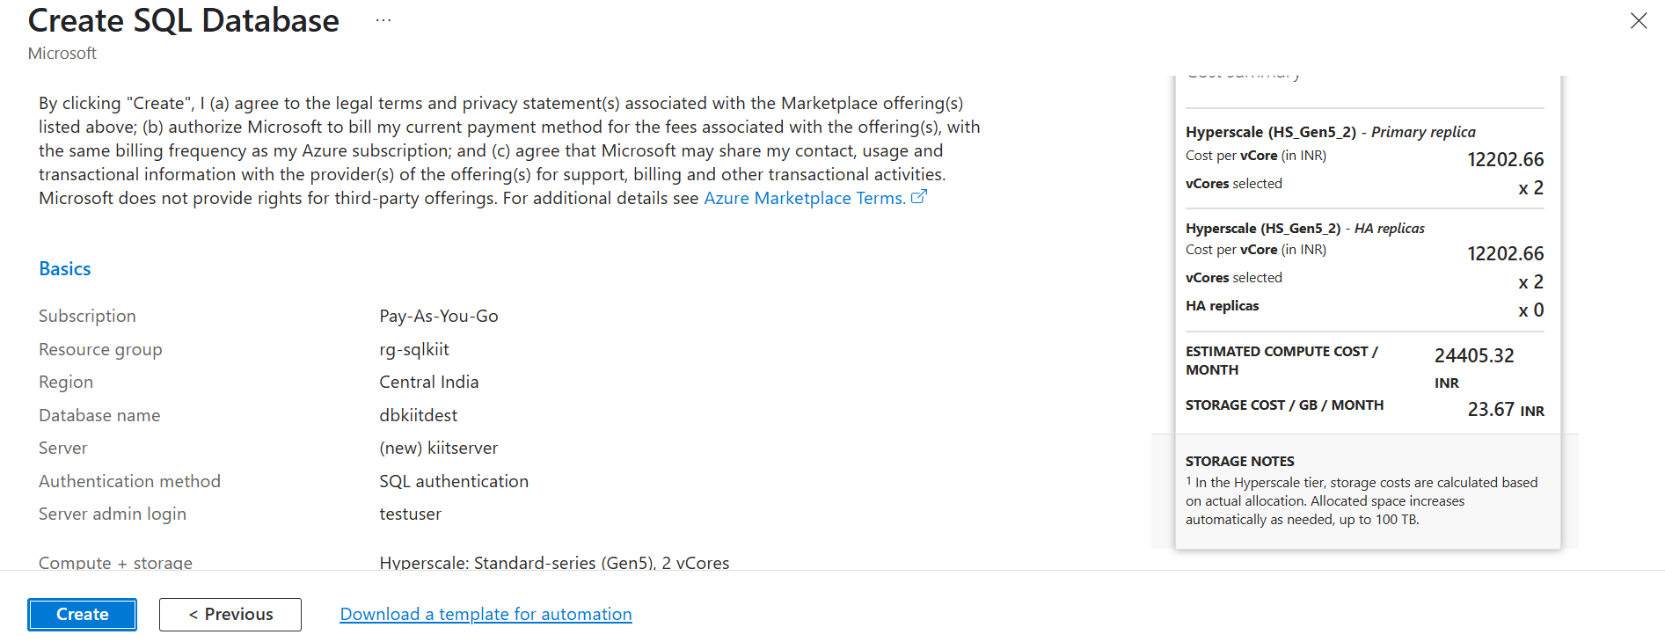

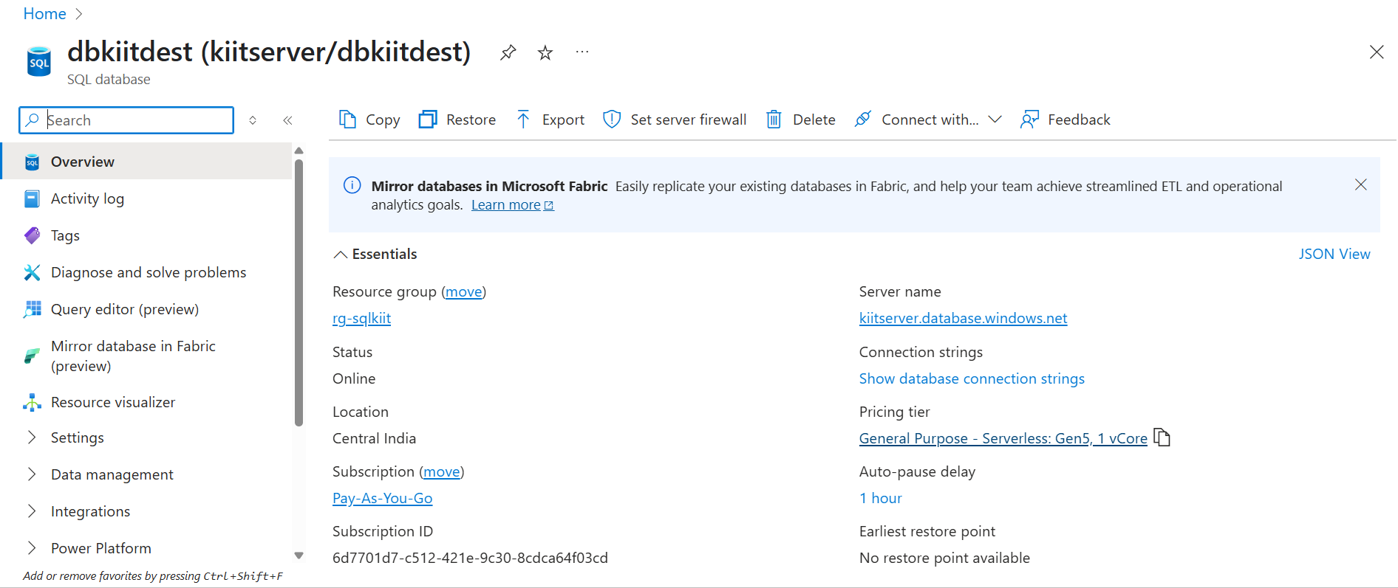
1. Again, go to Linked Services ➜ New.
2. Choose Azure SQL Database ➜ Name it e.g., LS_SQLDB.
3. Select your server, database, and enter authentication details ➜ Test ➜ Create.
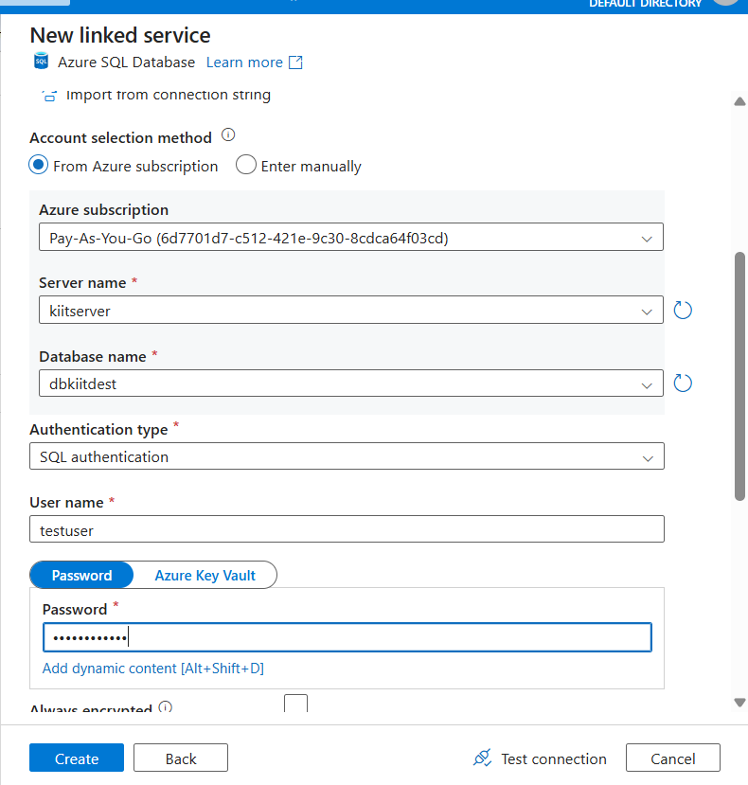
🎯 Linked Services act as connectors to your data sources and destinations.

✅ Step 3: Create Datasets
- 🔸 Dataset for Source (CSV file in Blob):
- 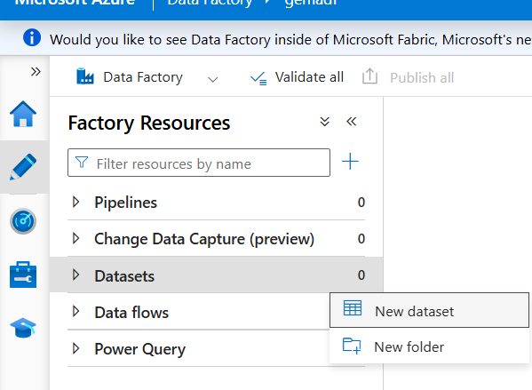
- Go to Author ➜ Datasets ➜ Click New Dataset ➜ Choose Azure Blob Storage ➜ Format: DelimitedText (CSV).
- 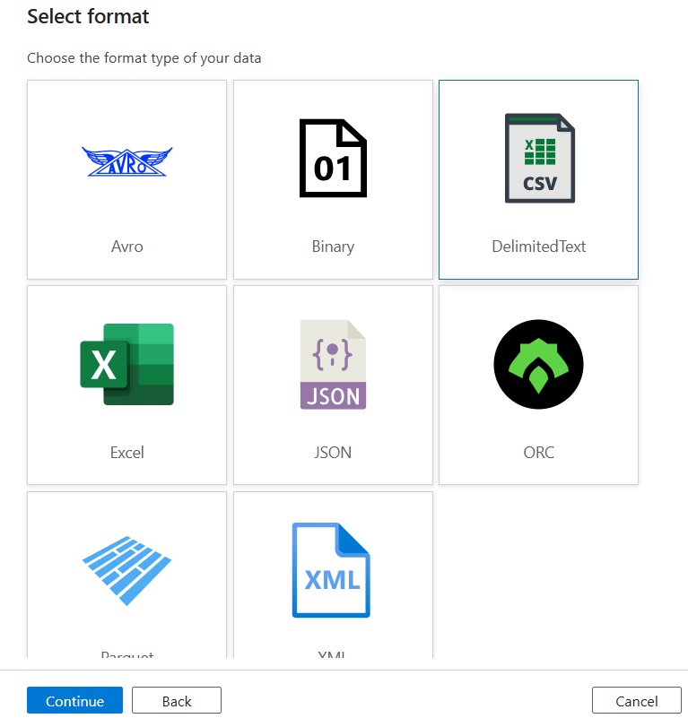
2. Name it DS_SourceCSV, select Linked Service: LS_BlobStorage, and browse to your file.
- 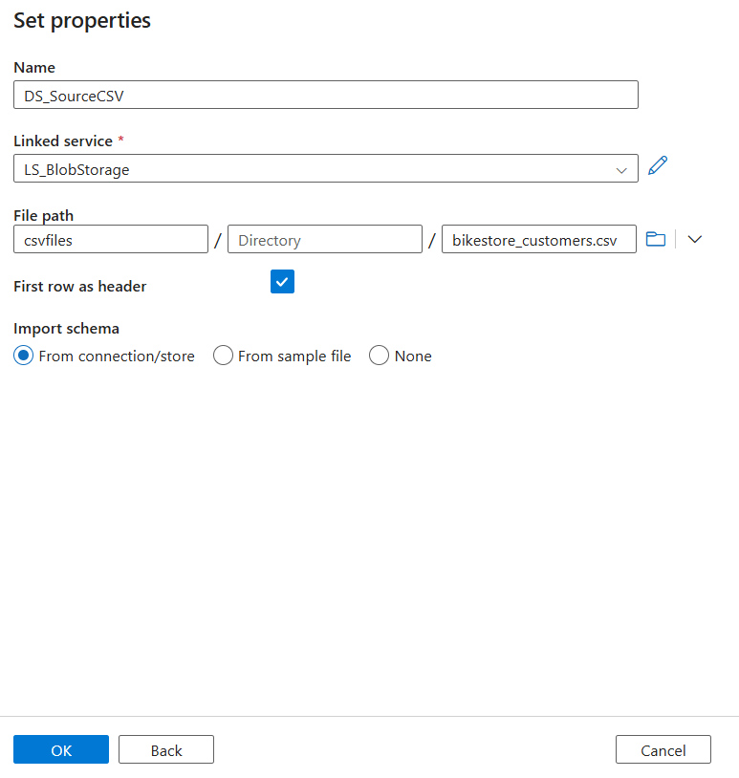
3. Specify first row as header, delimiter (e.g., comma), etc.
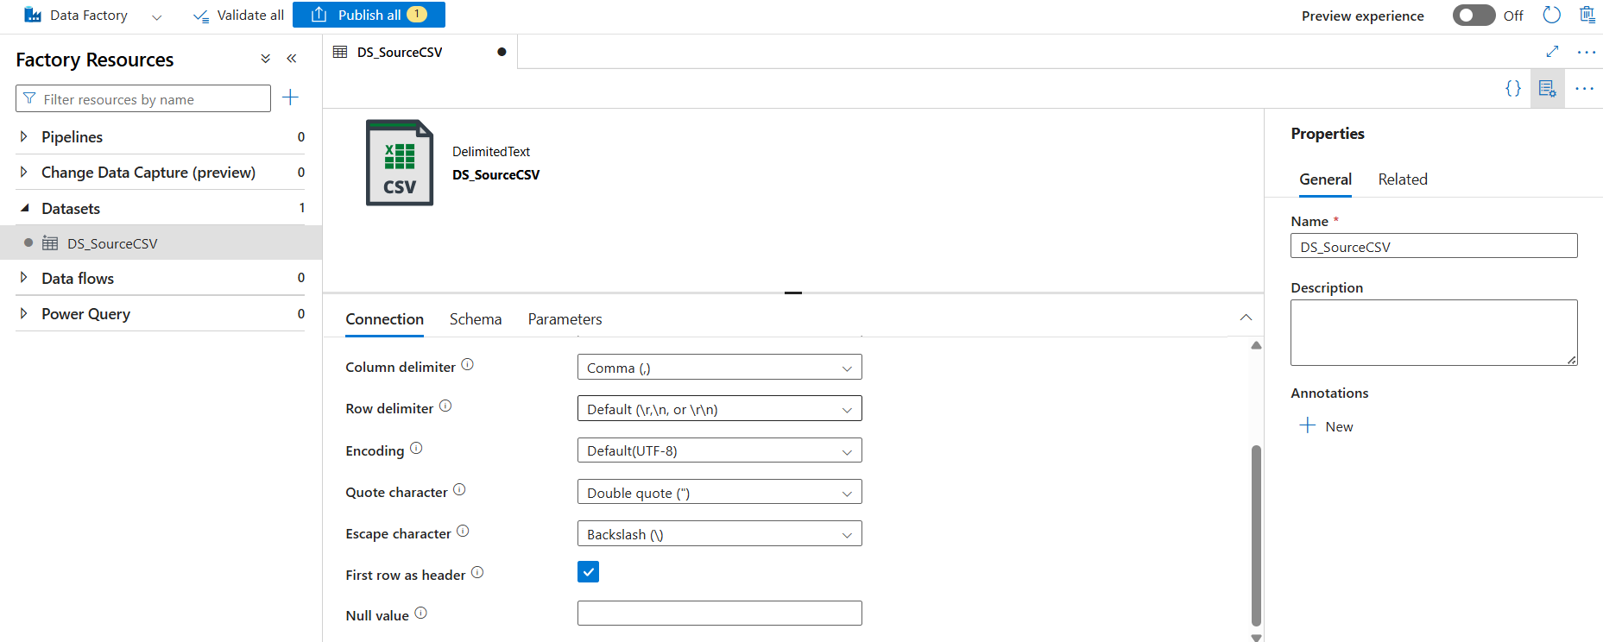
- 🔸 Dataset for Sink (SQL Table):
1. New Dataset ➜ Choose Azure SQL Database ➜ Select the LS_SQLDB.
2. Name it DS_SinkSQL ➜ Choose or create a target table.
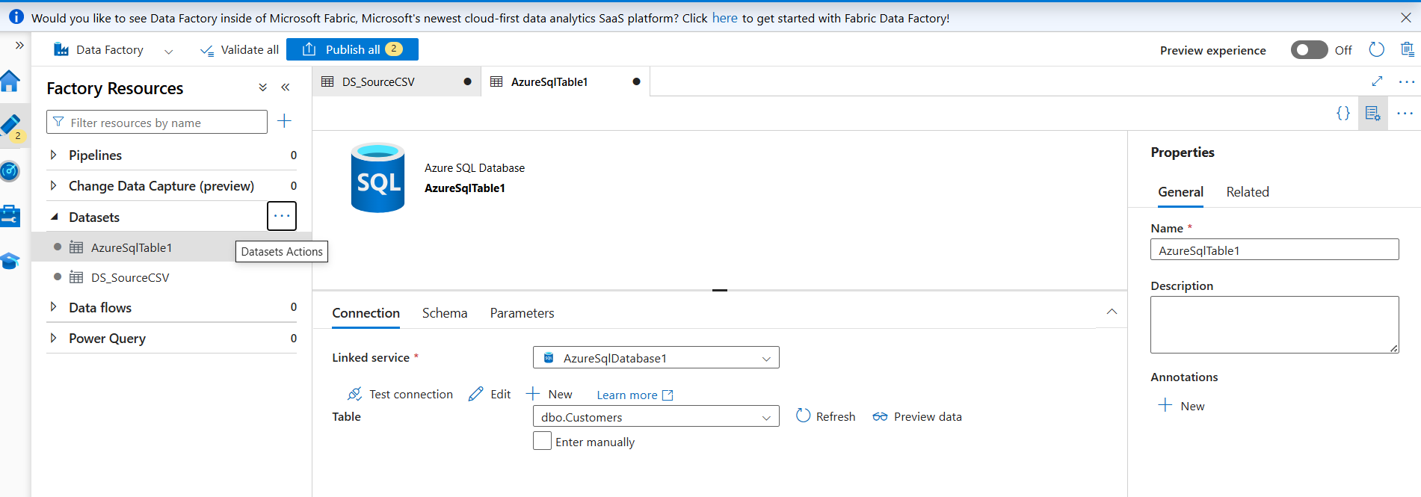
🎯 Datasets define the data structures used in the ETL process.

✅ Step 4: Create a Data Flow (Transform Layer)
- Go to Author ➜ Click on Data flows ➜ New Mapping Data Flow.
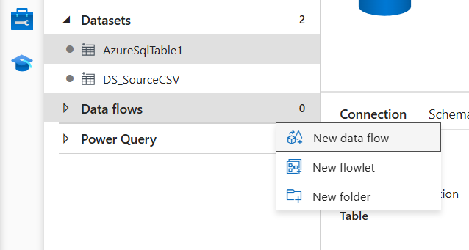
2. Add Source:
- Point to DS_SourceCSV.
- Inspect schema.
3. Add Transformations (optional but common ones include):
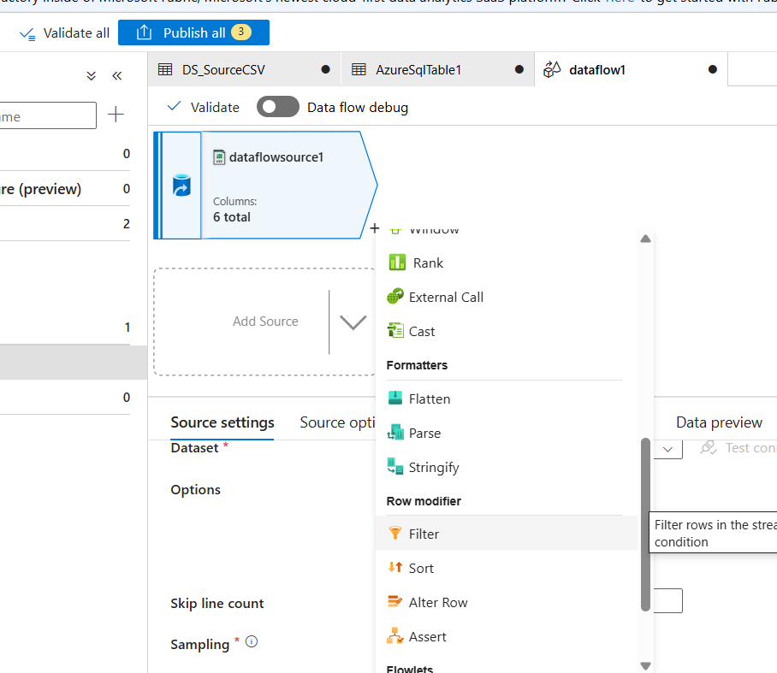
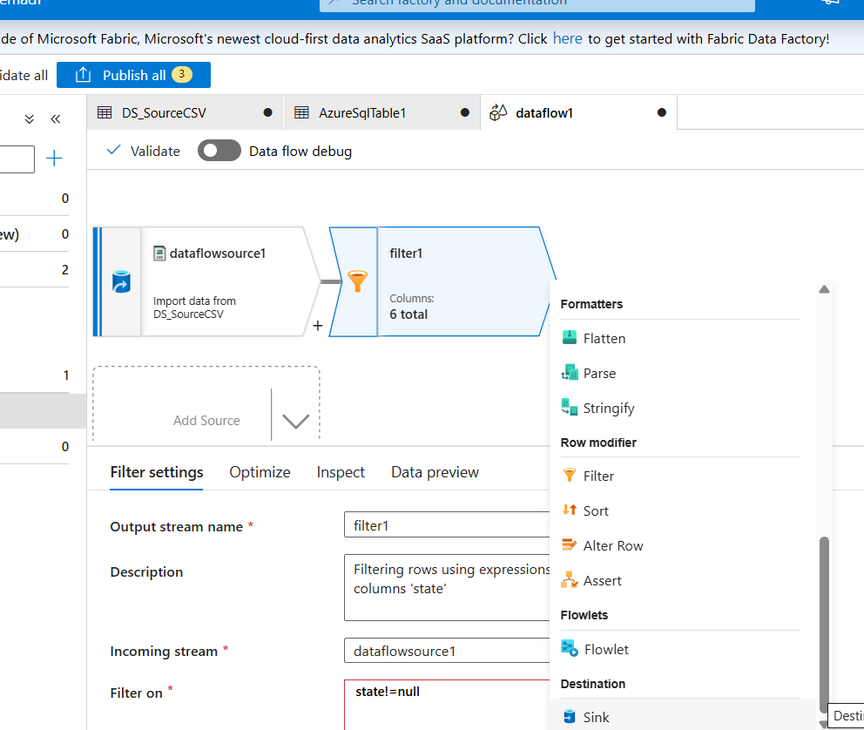

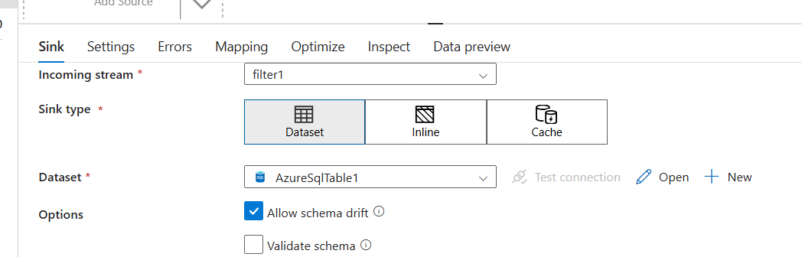

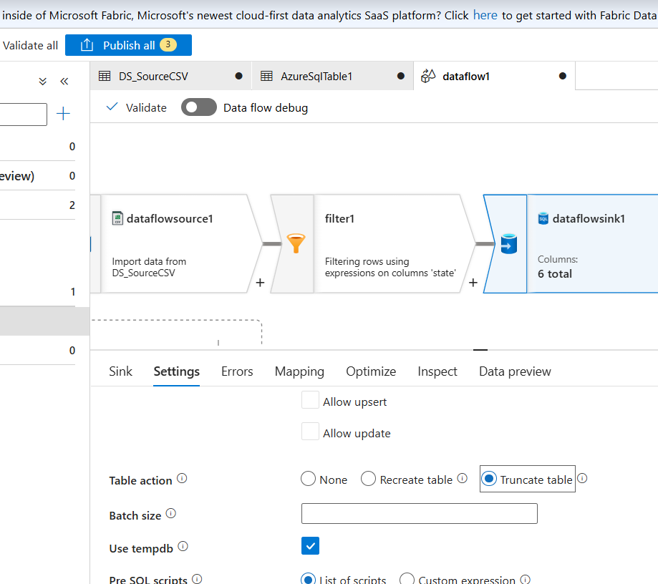

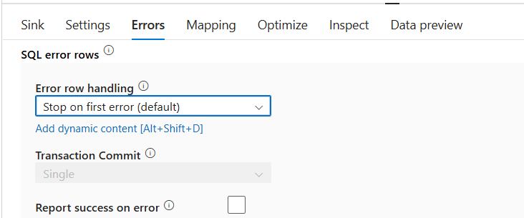

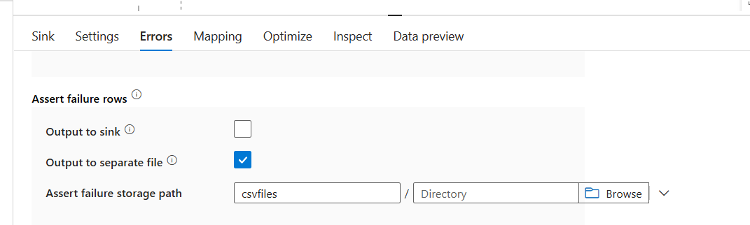

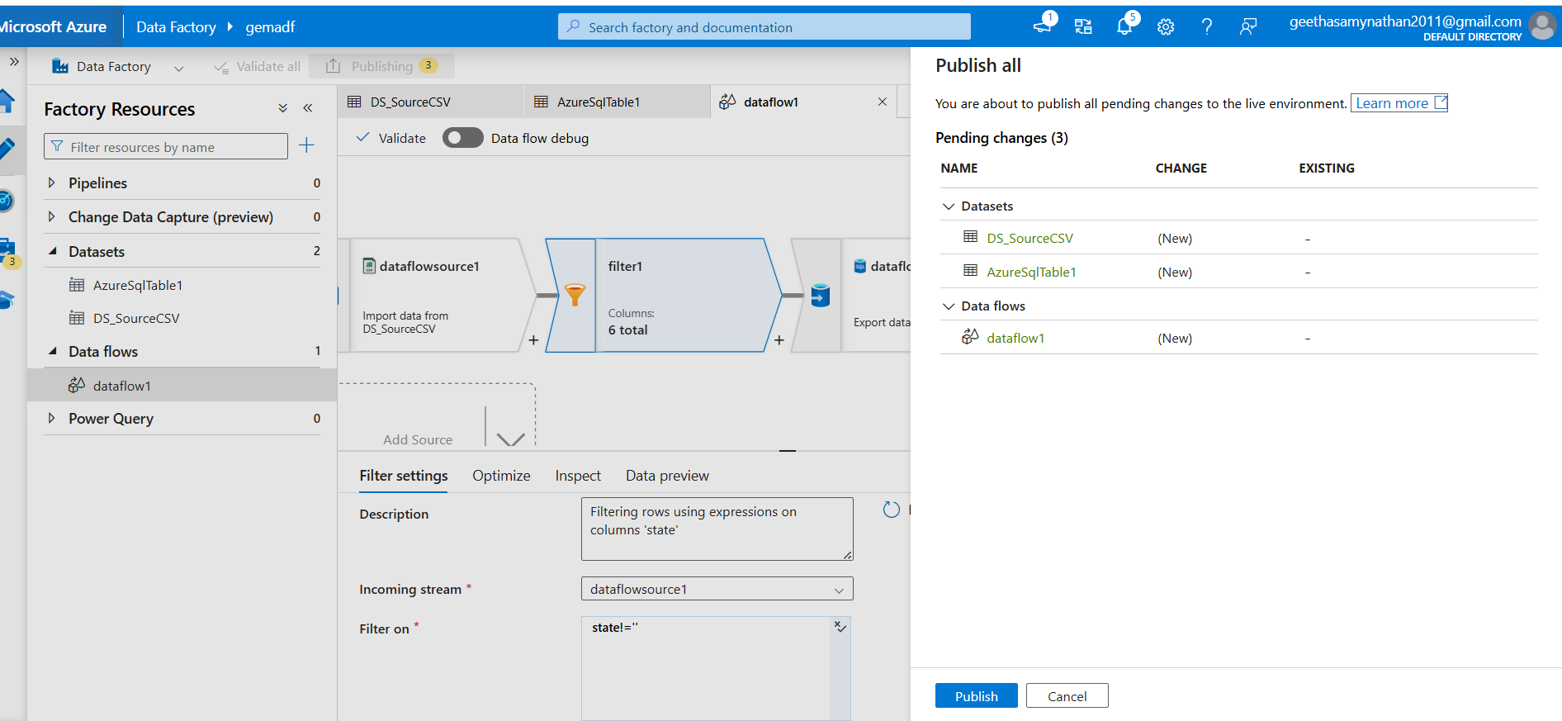
- Select: Choose only required columns.
- Filter: Remove rows with null values.
- Derived Column: Modify or create new columns.
4. Add Sink:
- Point to DS_SinkSQL.
- Choose to insert, update, or upsert.
5. Debug and publish.
🎯 Mapping Data Flows enable scalable data transformations without writing code.

✅ Step 5: Create and Configure a Pipeline
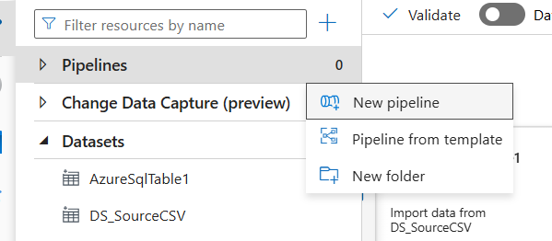
- Go to Author ➜ Pipelines ➜ Click New pipeline.
2. Drag Data Flow activity to the canvas.
3. In the Settings, choose your created Data Flow.
- 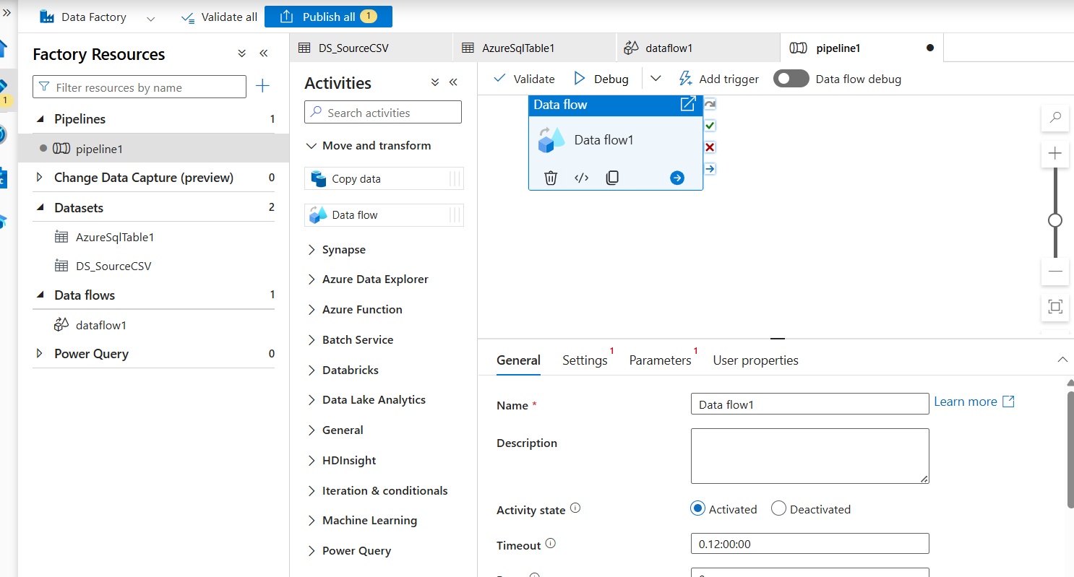
- 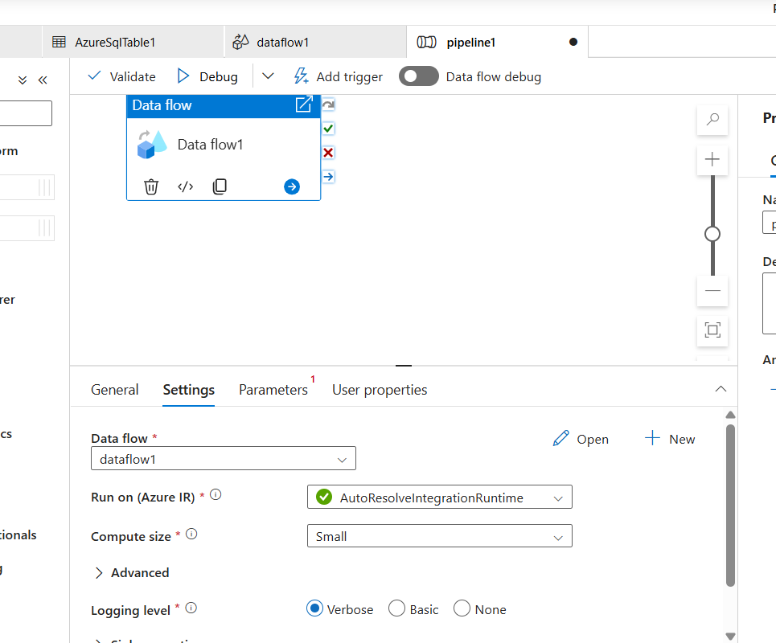

- 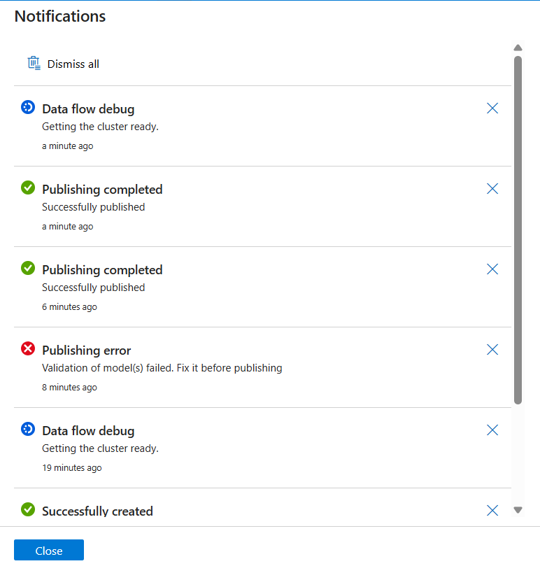
4. (Optional) Add other activities like:
- Wait
- If Condition
- Lookup
🎯 The pipeline orchestrates the full ETL workflow including scheduling and monitoring.

✅ Step 6: Trigger and Monitor the Pipeline
1. Click Add Trigger ➜ Choose Trigger Now or create a Scheduled Trigger.
2. Go to Monitor tab to see:
- Activity Runs
- Status (Success/Failure)
- Duration and Logs
🎯 This ensures your ETL process is running as expected and allows for diagnostics.

📌 Summary Table
Step | Component | Purpose
1 | ADF Instance | Setup orchestration environment
2 | Linked Services | Connect to data sources and destinations
3 | Datasets | Define data structures
4 | Data Flow | Apply transformation logic
5 | Pipeline | Sequence the ETL steps
6 | Trigger & Monitor | Run and supervise execution

